Chapter 6
Fungal reproduction
Understanding how fungi reproduce can help cultivators understand how these organisms disperse in a given ecosystem. Most fungi create spores when they reproduce sexually. Certain species can also reproduce asexually. An alternate way filamentous fungi (and cultivators) can disperse to new territory is via fragments of mycelium.
One of the reasons why fungi are so successful and therefore so ubiquitous in nature is due to their mode of reproduction: spores. Most species of fungi can produce spores in incredible quantities. The ability of fungi to produce so many spores increases the chance that at least some of them will land in a suitable environment where they can germinate and begin the process all over again. Spores can be a result of sexual reproduction, involving meiosis and genetic recombination. Or they can be produced asexually, where genetic clones of the parent are produced via mitosis. Some fungi produce only sexual spores or only asexual spores (conidiospores), while others may be capable of both sexual and asexual spore production.
Spores also vary quite drastically in shape and size. As a matter of fact, spore shape/size/features/colors/staining-ability are often extremely useful tools in identifying fungi. Characteristics relevant to spore development on the reproductive part of the fungus can be another useful tool in identifying unknown fungi.
Similar to the importance of flower and reproductive morphology for identifying plants, the reproductive parts of fungi often reveal evolutionarily-conserved, diagnostic features that are more readily differentiated than vegetative tissue. The characteristics of reproductive tissue are less likely than vegetative tissue to change drastically through evolutionary time. This is likely because the precision of reproduction, and therefore its relevant tissues, are so fundamental to survival of a species across generations. Vegetative structures, on the other hand, may be more flexible to change in the face of shifting selective pressures due to the wider range of acceptable functionality of such tissues. Therefore, vegetative characters often appear similar, even among relatively unrelated organisms; an artifact of convergent evolution.

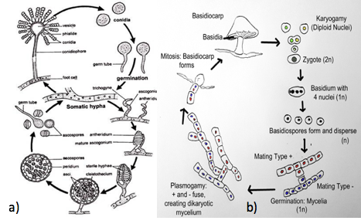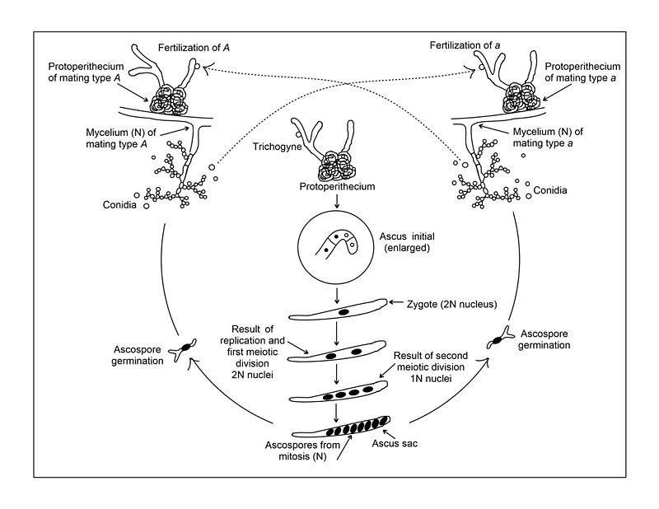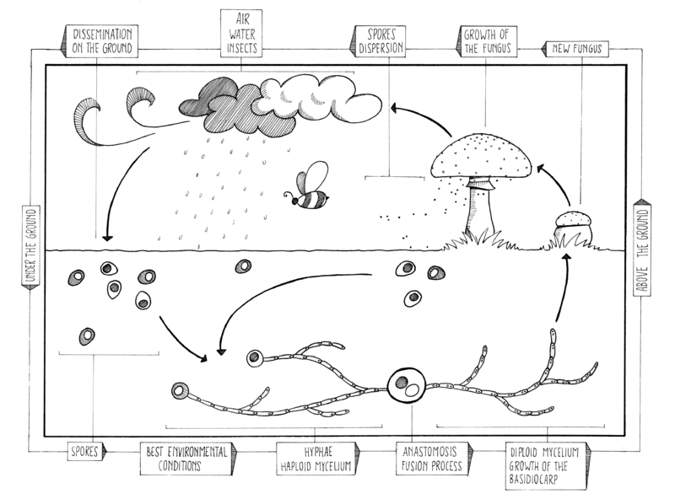
Figure 6.1. Life cycle of an Ascomycete (a biologydiscussion.com/fungi/aspergillus-habitat-reproduction-and-importance-ascomycotina/24000) and Basidiomycete (bstudy.com/academy/lesson/basidiomycota-life-cycle.html) fungus.

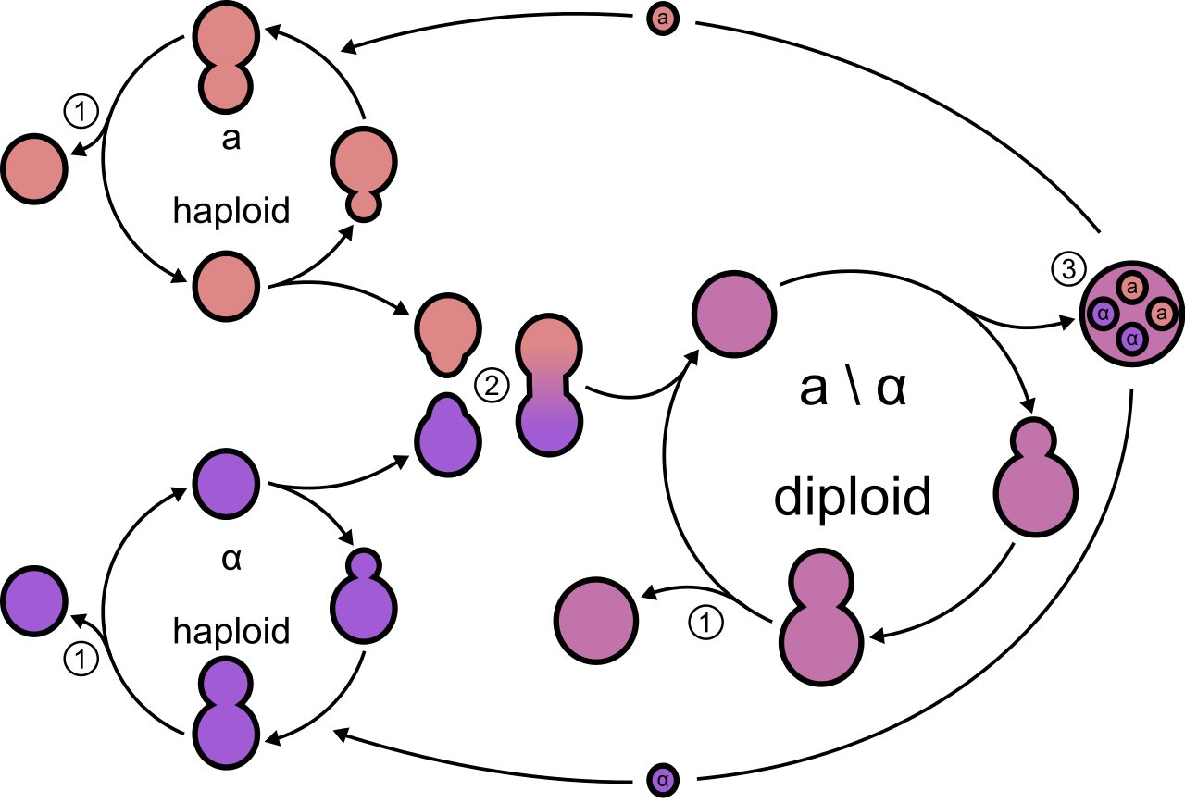
Figure 6.2. Lifecycle of the ascomycete yeast, Saccharomyces cerevisiae. Both haploid and diploid Saccharomyces sp. undergo asexual reproduction by budding (1). Compatible haploid individuals undergo sexual reproduction by conjugation to form a diploid individual (2) followed by haploid spore formation (3). Saccharomyces sp. only form 4 haploid spores in their asci, as opposed to the standard eight among most ascomycete fungi. Wikicommons user Masur

All fungi begin life as a spore (Figure 6.1). The spore can then germinate into either a hypha or a yeast, depending on the species. For some dimorphic species (capable of growth as a yeast or a filamentous mycelium), environmental interactions will determine their growth form. If filamentous, the hyphae will grow, secreting extracellular enzymes (exoenzymes) into their environment, allowing the fungi to penetrate and grow through substrate, in three dimensions. Most fungi that grow from spores possess genetically uniform nuclei (an exception to this may be the multinucleate spores of the Glomeromycota). When a hypha has only one type of nucleus in the cell, it is called monokaryotic.

Homothallism and Heterothallism
Fungi that require another individual with which to mate sexually are called heterothallic (hetero=different, thallus=body). When one monokaryotic hyphae meets another mating-compatible hypha, the two will fuse cell walls and plasma membranes (plasmogamy) and transfer cellular contents, including nuclei. The resulting mycelium is now dikaryotic and contains two types of genetically distinct nuclei (dikaryon = n+n; where “n” = a complete haploid genome).
The two different types of nuclei live separately in the same cell until the environment signals to the fungus that it is time to reproduce. At that time, the two nuclei fuse (karyogamy, resulting in a 2n=diploid) and fertilization takes place forming a zygote. This zygote undergoes meiotic (reductive) division. This results in genetically recombinant, sexual spores. Sexual spores produced by heterothallic fungi get half their genetic material from one parent and half from the other parent (similar to us). Some heterothallic species can undergo asexual reproduction in order to create replicas of itself to further its distribution without finding a mate. This not only effectively reproduces a successful individual clonally, but also increases the chance of sexual reproduction by disseminating to other suitable areas where a compatible mate may be found.
Some fungi are capable of sexual reproduction with themselves. Fungi capable of this feat are referred to as homothallic (homo=same, thallus=body). Homothallic fungi also undergo karyogamy (fusion of 2 nuclei), followed by meiosis in order to form haploid, sexual spores. While meiosis still occurs in these fungi, repeated selfing limits the variation introduced during sexual recombination, compared to outcrossing (heterothallic) species. Self fertilization increases homozygosity of alleles across all loci of the progeny compared to the parent (or maintains the preexisting homozygosity of the parent with the exception of de novo mutations).
Homothallism and heterothallism each have potential benefits and drawbacks for the fungus species. Heterothallic fungi may increase the chance they will benefit from the well known advantages of sexual recombination of different genotypes by forcing the mycelia arising from two separate spores to meet before sexual recombination occurs. Though, it should be noted that many heterothallic fungi can mate with their spore-siblings (1n) if they are of compatible mating type in what would be akin to a diploid plant ‘selfing’ ( Coelho, 2017). Recombination between different parent genomes permits the creation of highly variable and novel genotypes everytime sexual reproduction occurs. Such varied genepool are fodder for the evolutionary process to “naturally select” the best performing combinations from a wide pool of possibilities.

Homothallic fungi, on the other hand, may have found success by taking an opposite approach. Homothallic fungi are fungi whose mycelia can mate with every other mycelia in the population, including itself. Homothallic fungi are prone to inbreeding. Among organisms that normally outcross, inbreeding exposes defective, recessive alleles resulting in loss of vigor, and mutants, a phenomenon known as inbreeding depression. However, among organisms that regularly inbreed, such as homothallic fungi or self-fertilizing plants, this generally does not occur. Presumably such inbreeding species have not tolerated the covert accumulation of defective recessive alleles, which would quickly present themselves among inbred offspring when homozygous. While the offspring of homothallic fungi may be much less diverse than those of heterothallic species, this can be beneficial if the parent is a superior genotype. In this way, favorable multilocus genotypes may be maintained across generations though inbreeding (Allred 1960). In light of this, relatively infrequent outcrossing events can be important sources of variation for the evolution of such species. Additionally, homothallic fungi may be at an advantage in situations where mates are infrequently encountered (the lonely spore hypothesis) (Kendrick, 2001).
While meiosis is recognized to increase diversity through sexual recombination, it also serves other purposes. Even in predominantly inbreeding species, including many homothallic fungi,, meiosis may also serve to increase resistance to DNA damage via homologous meiotic recombinational repair (Hernstein, 1987).
Dikarya, the “Higher” Fungi
Basidiomycota and Ascomycota are known as the dikarya. Dikarya refers to their habit of forming a dikaryon. A dikaryon forms when two compatible haploid (1n) individuals fuse cell membranes, a process called plasmogamy. In Opisthokonta other than the Dikarya, including humans, karyogamy (the fusion of the two nuclei) immediately follows plasmogamy (the fusion of cell membranes). This results in a diploid (2n) individual. In the Basido- and Ascomycota, following plasmogamy the nuclei pair-off without fusing, forming a dikaryon (n+n) with two distinct nuclear types -one from each parent individual.
Clamp connections among Basidiomycota may maintain individual, n+n cellular compartments, and this dikaryotic hyphae may grow and exist in this state for long periods of time (Figure 3.4). Dikaryotic Ascomycota have porate septa; they are functionally coenocytic cells and usually only exist as literal dikaryons (with two, heterogeneous nuclei) in the ascogenous hyphae, occuring in the fruiting bodies, where ascospores are produced. Conidia produced by a dikaryotic mycelium can sometimes be multinucleate or multicellular and maintain a dikaryotic state through asexual reproduction.

Basidiomycota
In Basidiomycota, the spore will germinate and the haploid hyphae will grow. Heterothallic fungi will search for a compatible mating type. If they contact a fitting individual, their bodies will fuse (plasmogamy), joining cytoplasm to create a single individual. The resulting mycelia is dikaryotic, meaning it has two genetically distinct types of nuclei that have not fused. As the hyphal tips grow, a unique type of septum, a dolipore septum, will form. When this feature forms, a clamp connection will form as well, securing two distinct nuclei per hyphal section. The dolipore septum has a membrane covering the septal pore that blocks certain organelles (including nuclei) from passing, maintaining the dikaryotic state.
When environmental conditions are correct (which may not occur for long periods of time) the fungus will differentiate specialized fruiting bodies, also called a basidiome (previously basidiocarp). Spores are produced in an area of the fruiting body called the lamella. Within cells of the lamella, the two (n+n) nuclei will fuse and a basidium, a club-like structure, forms. After the fusion of the two haploid nuclei, a diploid zygote is formed. This is the only portion of the fungal life cycle that is diploid (2n). Immediately following this, meiosis occurs, resulting in four, genetically-different daughter nuclei (1n). Each of these nuclei become a spore that is borne on the tips of the basidia. Among mushroom producing species, basidia are formed on the fertile surfaces of the fruiting body, i.e., the gills or pores of a mushroom (i.e the lamella). Some Basidomycetes are also capable of asexual spore production, permitting reproduction and dispersal without a mate or fruiting body formation.

Ascomycota
In Ascomycota, again a haploid mycelium grows from a single spore. Among heterothallic species, if a suitable mate is encountered, the hyphae fuse to form dikaryotic hyphae. Ascomycete fungi do form septa, however these fungi have a septal pore that is not covered by selective membranes (parenthesomes) and thus, nuclei and other organelles are free to travel. This has several implications. First, since nuclei are not restrained to a particular section of the hyphae, there tends to be a lot of nuclear movement and a particularly high concentration of nuclei at the growing tips.
In both heterothallic and homothallic ascomycetes, when sexual reproduction takes place, specialized structures known as an ascogonium and antheridium form. The antheridium coils around the ascogonium. After fusing together and transferring nuclei, karyogamy (joining of two nuclei to form a diploid) occurs. The resulting diploid zygote undergoes meiosis, producing four genetically unique nuclei. These four nuclei then (usually) undergo a round of mitosis, resulting in eight total nuclei that are each destined to become a spore. This happens inside of the ascus (plural asci).
Asexual spore formation is extremely common among ascomycetes. Mitotic reproduction results in genetically identical offspring and is less energy intensive than meiosis. Because of this, fungi can produce asexual spores in great number and in a relatively short period of time. Certain fungi can even produce multiple types of asexual spores, such as macroconidia, microconidia, and chlamydospore, given varying environmental conditions and species propensities.
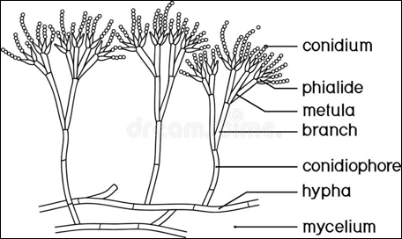
Fig. 6.6. Conidiophores (sexual spore producing structures) of a typical Ascomycete fungus (diagramed is a spp. of Penicillium).

Asexual spores (also called mitotic spores and conidiospores) are haploid and are produced on specialized hyphal structures referred to as conidiophores (Figure 6.xx). Conidiophores are produced behind the spitzenkorper and will arise from vegetative hyphae. The specialized structures can look drastically different from fungus to fungus and historically have been used to classify different groups of fungi.
The hyphae erecting directly from the vegetative tissue is called the conidiophore. There is typically a specialized cell beneath the spores where the conidia are actually produced. This is called the conidiogenous cell. Condia produced from this cell may develop in different ways, which we will not detail here, but are able to serve as useful morphological characters for identification purposes.

Figure 6.7
It is important to understand that some filamentous fungi can produce asexually in addition to sexual reproduction. Understanding how particular fungi grow and reproduce can help us better develop sustainable treatments to protect crops and animals against certain pathogens.

Vegetative Compatibility
Some fungi have an additional mechanism governing anastomosis (hyphal fusion) and plasmogamy beyond mating type compatibility. Vegetative compatibility is a self/self recognition system which allows fungi to form complex, reticulated mycelial networks by fusing each time hyphae from the same (or compatible) individual come in contact. This ability to form netted connections confers additional benefits for filamentous fungal growth, such as improved resource acquisition and increased ability for cytoplasmic flow throughout the fungal body.
Vegetative compatibility also offers a way to increase genetic diversity. If the hypha of two genetically unique individuals of the same vegetative compatibility group meet, their hyphae will also fuse. So it's more of a self/close-enough-to-self recognition system. In fact, this system only operates after hyphal fusion; if the hyphae are not compatible the bridge of cells are killed by programmed cell death. In this way, sometimes incompatible individuals may transfer some cytoplasm (potentially along with genetic information, endosymbionts, or viruses) before the connection is severed. When the individuals are compatible, the bridge is retained permitting cytoplasmic flow between the now connected mycelia. The resulting mycelium will contain two (or more as occurrences of vegetative anastomosis accumulate) heterogeneous nuclei. Hyphae frequently occurs in a multinucleate state via this mechanism.
This has important implications. The diversity of nuclei within an individual mycelium permits increased adaptive ability, conferring fitness to a wider range of potential environments. In multinucleate, coenocytic fungi -where nuclei may flow unrestricted-f the phenotype of a single mycelium may vary over the range of its body if the ratio of nuclear genotypes differs (a phenomenon known as sectoring when growing fungi in petri dishes). Certain nuclear genotypes may become more common if there is a selective advantage for them in a certain environment. Having a large concentration of nuclei at the growing tips allows the fungus to be highly adaptable. It has also been suggested that an excess of nuclei may serve as nitrogen and phosphorus sinks, available as needed through autophagy (Maheshwari, 2005).

Parasexual Cycle

Following vegetative anastomosis, some fungi, mostly among the asexual deuteromycota, are able to undergo a pseudosexual genetic reshuffling without the use of meiosis. Following anastomosis (plasmogamy), the hypha is in a dikaryotic state. In the parasexual cycle, two heterogeneous nuclei fuse (karyogamy) forming a single diploid nucleus (Fig. 6.X). A period of growth follows, with many cycles of mitotic divisions with crossing over. Some of the resulting diploid daughter nuclei then undergo haploidization through a series of aneuploid intermediates. Aneuploidy refers to aberrant chromosome numbers in a cell. This differs from polyploidy in that individual chromosomes may be missing or duplicated, rather than complete genome sets. Through this irregular parasexual cycle (Fig _6.X), nuclei containing recombinant genomes derived from two parents may be created without meiosis.

Yeasts

Most yeasts are ascomycetes, though some basidiomycetes also grow as yeasts (notably the human pathogen, Cryptococcus neoformans). Yeasts are commonly used to bioengineer certain compounds. In relationship to Cannabis, scientists have been able to insert the genes that produce CBD into certain yeast species (Yarrowia lypolitica) that, when grown in a sterile broth medium exudes these cannabinoids into the liquid which can the be extracted and isolated out from the solution. This can be done in the fraction of the time it takes to grow a plant.
Yeasts can reproduce mitotically (asexually) for an indefinite amount of time given the proper conditions (Dujon 2010). This form of asexual reproduction can take the form of budding (Fig. X), where a parent cell will portion off a part of itself and will form a new genetically-identical daughter cell. Budding yeasts that divide asymmetrically or in stressful conditions can age and senesce over time, with a finite amount of daughter cells produced. Yeast cells can also perform sexual reproduction with genetic recombination.

Need to add info on yeast budding, sex, schmoo formation, spore germination, fission yeast

The “Lower” Fungi
The lower fungi are referred to in this way not because they are any less important. They are known as lower fungi because they lack dikaryon formation, which is an ancestral feature compared to the Dikarya (Basido- and Ascomycota). In the Glomeromycota, ‘Zygomycota,’ and Chytridiomycota dikaryon formation is not observed. Glomeromycota are not known to reproduce sexually, whereas among the ‘Zygomycota’ and Chytridiomycota plasmogamy and karyogamy occur as a linked process (without an extended n+n dikaryon vegetative phase).
While they may appear “lower,” or more primitive when visualized on a phylogenetic tree, and are referred to as such, one must remember that all extant organisms have evolved for exactly the same amount of time from our most recent common ancestor. None are higher or lower in terms of evolution. All extant species are by definition evolutionarily successful in terms of survival (though the roll of extant species is constantly changing). Perhaps better terms would be “more-” or “less-derived” from an ancestral state. However, “higher-” and “lower-” are persistent historical terms unlikely to be dropped by a species that prefers to think of themselves as the “highest” branch on the evolutionary tree.

Glomeromycotina
Reproduction in the Glomeromycotina (arbuscular mycorrhizal fungi) is a little different and not very well understood. There has long been debate as to whether sexual reproduction occurs in the Glomeromycotina. Indirect molecular evidence is accumulating that meiosis does occur, though the mechanism is unclear; an uninucleate cell (thought to be a prerequisite for meiosis) has not yet been observed (Bruns et al 2017).
Producers of mycorrhizal inoculants use asexual spores. These spores are usually produced at the terminal ends of hyphae, though some mycorrhizal fungi can produce asexual spores intercalary, or in the middle of growing hyphae. Regardless if they are at the tip of a hypha or found in between growing hyphae, they are referred to as glomerospores, a specific type of chlamydospore. Chlamydospores are thick walled, asexual, resting structures that are capable of surviving long periods of time, even in harsh conditions. Typically, when mycorrhizal products are sold, the label will have a guaranteed minimum of fungi in the product. This is usually expressed as propagules per gram or spores per gram. ‘Propagules’ often includes hyphal fragments as well as spores. Spores have a longer shelf life than hyphal fragments.
These asexual spores are relatively large and are genetically identical to the parent fungus that produces the spores. However, many asexual glomerospores will often contain multiple different nuclei. Typically, spores of Glomeromycota require the presence of signals from plant roots in order for germination to occur.

‘Zygomycota’
The ‘Zygomycetes’ (Zoopagomycota and Mucoromycota) reproduce sexually when hyphae of two compatible mating types meet. Volatile chemical signals first prompt hyphae from individuals to grow towards each other, following contact between compatible hyphae. This complex physiological process results in the formation of a zygospore. A thickened, melanized protective wall forms around the Zygospore. Meiosis occurs following zygospore formation.

Chytridiomycota
The chytrids have the most ancestral lifecycle of the fungi. Haploid zoospores are formed via meiosis. These germinate into a thallus ranging from a single cell to a moderate hyphal network. Male and female gametes form. In some chytrids both gametes are both mobile with flagella. In others only the male gamete is motile. Some species produce asexual, motile zoospores. These can be haploid or diploid zoospores.
Interestingly, sterile hemp seeds are used as a bait for culturing some Chytrid spp.

Microsporidia
Being the smallest eukaryote, microsporidians were traditionally thought of as protozoans but with advances in molecular techniques, have been reclassified as reduced and specialized fungi (Corradi and keeling 2009). These reduced fungi reproduce by unicellular spores that have a polar filament but are lacking organelles typically found in eukaryotes such as the mitochondria and centrioles.

Even though microsporidians are obligate parasites that require a host to complete its life cycle, spores can survive outside of the host. Reproduction can vary from species to species and may even require an alternate host. As the spore enters an appropriate host, it will germinate and the polar filament will pierce the host cell and force the cellular contents of the spore into the host cell's cytoplasm. Eventually a tumor-like structure will form the host animal called a xenoma, that will begin to syphon nutrients and resources from the host.

The Non-Fungi
The following groups aren’t fungi. Oomycota are eukaryotic, like fungi, but are heterokonts, not opisthokonts. Actinobacteria are not even eukaryotic, they are true, prokaryotic bacteria.

Oomycota
Oomycetes can either reproduce sexually or asexually. Oomycetes begin life by germinating from a diploid oospore into a hyphal body form. For the asexual cycle, or the anamorph, water molds will produce a sporophore with a sporangium on top. The sporangium will release diploid mobile zoospores or non-mobile conidia, also called sporangiospores. The zoospores have flagella to help them move through aqueous environments. Zoospores can form cysts which act as long term storage structures. When the environment is favorable, the cyst can germinate and infect new host plants.
The haploid stage of oomycetes is much less extensive than the prolonged haploid growth that can occur in true fungi. The male (antheridium) and female (oogonium) form from a hyphal thallus via meiosis. The antheridium makes contact with the oogonium and transfers nuclei to each oosphere within the oogonium via a fertilization tube, resulting in diploid oospores. These oospores are genetically different from the parent molds. The newly formed oospores can then infect new plants and begin the life cycle again.

Asexual reproduction and Fungi Imperfecti, a.k.a the deuteromycota
Some fungi, unable to find or mate-switch themselves to a compatible partner, can reproduce asexually. Let's face it, sex is hard and consumes a great deal of energy. By reproducing via asexual means -creating genetically-identical copies of itself- the individual fungus is able to quickly expand its reach and colonize new territory without needing a mate. Who among us hasn’t imagined the utility of being able to clone oneself?
Every grouping of fungi (and non-fungi) listed above contain members capable of asexual spore formation and dispersal. Some fungi have only been observed to reproduce asexually. Those fungi are placed in a catch-all, artificial Phylum ‘deuteromycota’, or the imperfect fungi (fungi imperfecti). Sacrificing or reducing sexual recombination is a strategic risk that allows quick reproduction at the expense of variability. When conditions are favorable for a deuteromycota clone, it can quickly dominate. However, if conditions become unfavorable, they must survive by moving to new, favorable locations. Some deuteromycetes are able to generate genetic novelty through other mechanisms, such as via vegetative compatibility and the parasexual cycle.

Actinomycetota (formerly Actinobacteria)
Actinomycetota is a group of filamentous, gram positive bacteria also known as the Actinobacteria. Prokaryotes do not have sex, though they can exchange genetic material in other ways, such as conjugation and plasmid transfer. Actinobacteria reproduce via conidia, or in some species, their hyphae break up into arthrospores that resemble a typical free living rod bacteria (Fig. X).

Conclusion
Fungal reproduction is varied, with many successful strategies having developed that can seem quite different from sex among animals with which many readers are more familiar. Now that we have a better understanding of how fungi grow and reproduce we will look at some specific examples of how particular fungi interact with the Cannabis plant.

